CALL ALL
  MAP | 32
Hillside Road South Papatoetoe | Printed 1/1/2014
Do not Call
Margaret 7/2 and 25b Pah Road 76/1

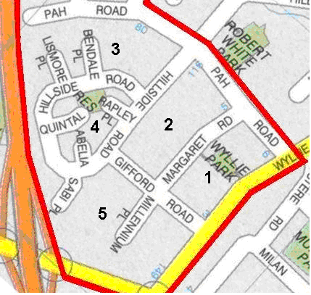

CALL ALL
  MAP | 32
Hillside Road South Papatoetoe | Printed 1/1/2014
Do not Call
Margaret 7/2 and 25b Pah Road 76/1

CALL ALL
  MAP | 32
Hillside Road South Papatoetoe | Printed 1/1/2014
Do not Call
Margaret 7/2 and 25b Pah Road 76/1

CALL ALL
  MAP | 32
Hillside Road South Papatoetoe | Printed 1/1/2014
Do not Call
Margaret 7/2 and 25b Pah Road 76/1

